Project Design Phase Problem – Solution Fit Template

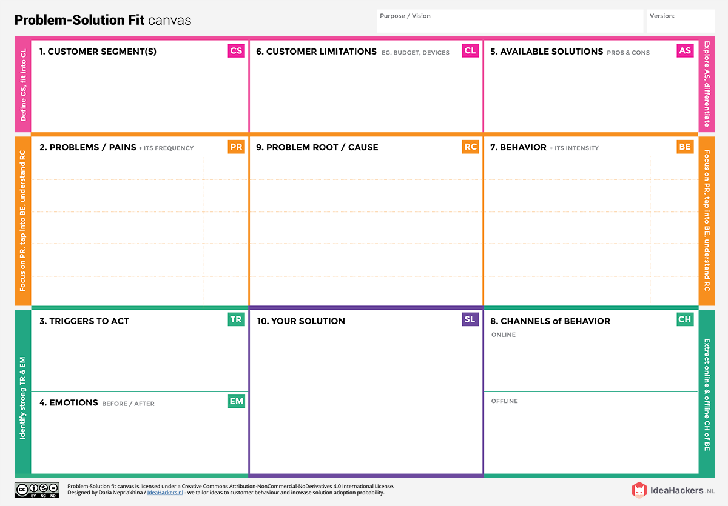

**Before**: Overwhelmed, reactive, uncertain about

Distributor reports and feedback sessions

Monitor product

feedback on e-commerce

A Tableau-based interactive dashboard that integrates product sales, consumer sentiment, and market

trends.

Negative online reviews or a dip in social media

|  |  |
| --- | --- |
| Date | 24 June 2025 |
| Team ID | LTVIP2025TMID48676 |
| Project Name | Cosmetic Insights |
| Maximum Marks | 2 Marks |

|  |  |  |  |
| --- | --- | --- | --- |
| Cosmetics brands, marketing managers, R&D  teams, and consumer | Budget constraints for advanced analytics tools |  | Basic analytics from social media platforms |

|  |  |  |
| --- | --- | --- |
| * Track market trends to stay ahead | * Decisions often based on intuition, not data | Product teams look at last |
| * Respond to negative feedback before it impacts brand trust | * Slow or delayed access to consumer feedback | quarter's sales before R&D planning |